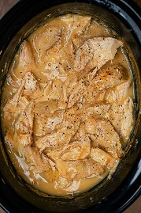 

A Recipe For:

# Slow Cooker Chicken and Gravy

**From the Kitchen of:** Mom

**Servings:** 4-6

**Prep Time:** 10 minutes **Bake Time:** 6-8 Hours **Bake Temp:**

**Ingredients:**

* 2 packets dry chicken gravy mix
* 1 10.5 oz can cream of chicken soup
* 2 cups water
* 1 lb boneless, skinless chicken breasts
* Garlic powder, salt and black pepper to taste
* ½ cup sour cream
* Rice, mashed potatoes or noodles for serving

**Instructions:**

1. Season chicken breast (both sides) with garlic powder, black pepper and just a tad bit of salt.
2. In you slow cooker, whisk together the gravy packets, cream of chicken soup and water until smooth.
3. Add the seasoned chicken breast. Be sure to get them covered in gravy.
4. Cover and cook on LOW for about 6-8 hours.
5. Once cooked, break chicken up into chunks using a fork.
6. Stir in sour cream (if using)

**Recipe Notes:**

The chicken gravy and cream of chicken soup already have salt in them so don’t go overboard on seasoning with salt (about ½ teaspoon should work).

Sour cream adds a great creaminess to this so I definitely recommend adding it in!

Serve over rice, mashed potatoes or noodles/